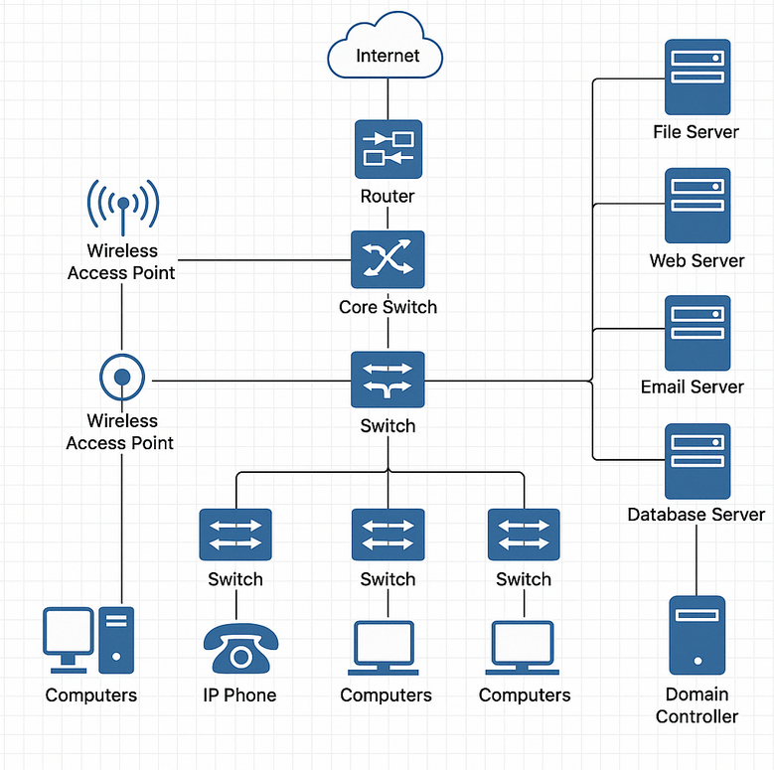

A computer network designfor a medium-sized company with about 150 employees, covering multiple departments like HR, IT, Finance, and Marketing. I'll give you the network layout, key components, and a diagram.

Company: TechNova Inc**.**

Location: Single office building (3 floors)  
Employees: ~150  
Departments:

* 1st Floor: Reception, HR, Finance
* 2nd Floor: Marketing, Sales
* 3rd Floor: IT, Server Room, Management

**Network Components**

* **Core Router** – connects company LAN to ISP
* **Firewall** – protects against external threats
* **Core Switch (Layer 3)** – routes traffic between VLANs
* **Access Switches (Layer 2)** – one per floor
* **Wireless Access Points** – one per department
* **Servers**:
  + File Server
  + Web Server (internal tools)
  + Email Server
  + Database Server (Finance/HR)
  + Domain Controller (Active Directory)
* **Client Devices**: Desktops, laptops, VoIP phones, printers
* **Network Segments**:
  + VLAN 10 – Management
  + VLAN 20 – IT
  + VLAN 30 – HR
  + VLAN 40 – Finance
  + VLAN 50 – Marketing/Sales
  + VLAN 60 – Guests (Wi-Fi only)

**Network Features**

* **DHCP**: Distributed by the domain controller
* **DNS**: Internal DNS for local resolution
* **VPN**: For remote work
* **Intrusion Detection System (IDS)** on a mirrored port
* **Guest Wi-Fi** isolated via VLAN 60
* **Redundant internet connection** with failover

**Internal (Private) IP Addresses**

**Servers**

* Domain Controller: 192.168.10.2
* File Server: 192.168.10.3
* Web Server: 192.168.10.4
* Email Server: 192.168.10.5
* Database Server: 192.168.10.6

**Core Network Devices**

* Core Router: 192.168.1.1
* Firewall: 192.168.1.2
* Core Switch (L3): 192.168.1.3

**Access Switches (L2)**

* 1st Floor Switch: 192.168.2.1
* 2nd Floor Switch: 192.168.3.1
* 3rd Floor Switch: 192.168.4.1

**Wireless Access Points**

* HR/AP: 192.168.2.100
* Marketing/AP: 192.168.3.100
* IT/AP: 192.168.4.100
* Guest Wi-Fi/AP: 192.168.5.100

**Clients**

* HR Desktops: 192.168.2.10 - 192.168.2.50
* Finance Desktops: 192.168.2.51 - 192.168.2.90
* Marketing/Sales: 192.168.3.10 - 192.168.3.90
* IT: 192.168.4.10 - 192.168.4.50
* Management: 192.168.4.51 - 192.168.4.90

**External (Public-Facing) IP Addresses**

WAN IP of Company: 203.0.113.10

VPN Gateway: 203.0.113.11

Public Web Server: 203.0.113.12

Email Server (External SMTP): 203.0.113.13