Secure Server: Building and Testing a Hardened Linux Web Server

Project Report
Overview
This project involved setting up a virtualized Linux server and securing it using a variety of hardware and software security tools. The main goal was to simulate a small-scale, real-world cybersecurity lab environment. The project focused on the installation, configuration, testing, hardening, and documentation of the tools used. By implementing and testing these tools, we gained hands-on experience in protecting and maintaining the security of a system.

Environment Setup
To carry out the project, a virtualized environment was created using VirtualBox. Ubuntu Server 22.04 LTS was chosen as the operating system for its stability and support in security applications. The server was configured with 2 GB of RAM, 2 CPU cores, and 20 GB of disk space, ensuring sufficient resources for testing security tools without excessive overhead.

Tools Installed and Tested
Tool Category | Tool Used
Port Scanner | Nmap
Vulnerability Detection System | OpenVAS (Greenbone)
Intrusion Detection System | Snort
Firewall | UFW (Uncomplicated Firewall)
Anti-virus | ClamAV
System Hardening | Lynis
Patch Management | APT + Unattended-upgrades
Auditing/Assessment | Lynis + Manual Checklists

Installation and Configuration
Port Scanner (Nmap)
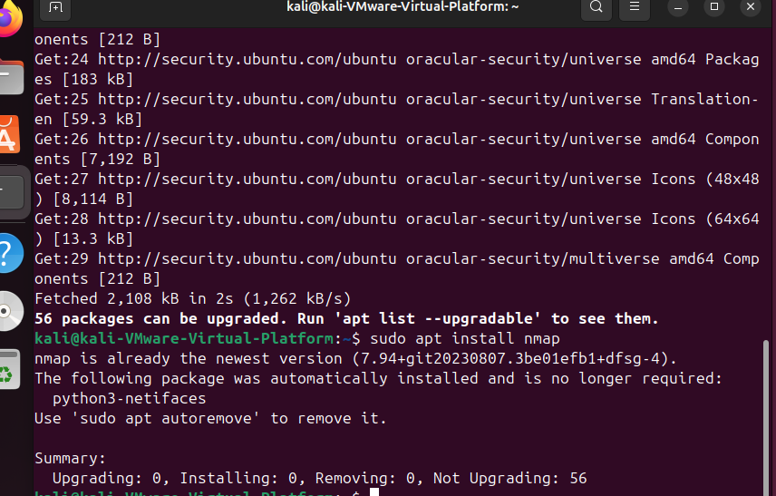
Nmap is an open-source network scanner used to discover hosts and services on a computer network. It was installed and used to scan localhost (127.0.0.1), confirming only necessary ports were open.
sudo apt update
sudo apt install nmap
Vulnerability Detection (OpenVAS)
OpenVAS is a full-featured vulnerability scanner. Installation and setup involved initializing the Greenbone Vulnerability Management system and checking its configuration.
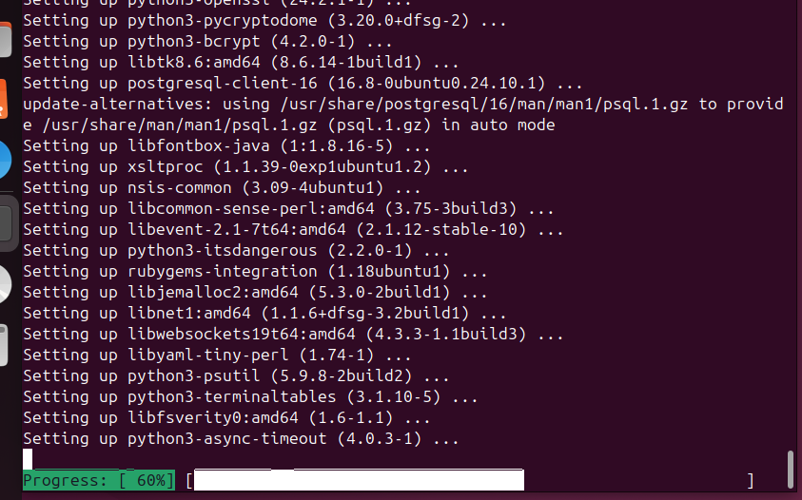
sudo apt install openvas
sudo gvm-setup
sudo gvm-check-setup
A vulnerability scan was performed on the server to identify any weaknesses.
Intrusion Detection System (Snort)
Snort was installed to detect network-based attacks. It was configured to monitor the "eth0" interface and customized rules were written to detect port scans.
sudo apt install snort
Firewall (UFW)
UFW was installed and configured to allow only SSH and HTTP traffic while blocking all other incoming connections.
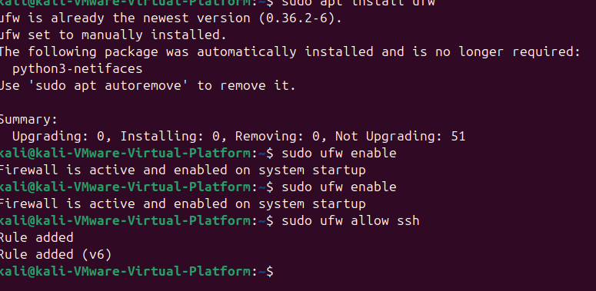
sudo apt install ufw
sudo ufw enable
sudo ufw allow ssh
sudo ufw allow 80/tcp
sudo ufw default deny incoming
sudo ufw default allow outgoing
Anti-virus (ClamAV)
ClamAV was installed for malware detection and removal. After updating the virus definitions with "freshclam," a full system scan was conducted.
sudo apt install clamav clamav-daemon
sudo freshclam
sudo clamscan -r / a million oks’ will spawn on your screen takes like 10 minutes to finished
System Hardening (Lynis)
Lynis was used for system auditing and hardening. After running an audit, a comprehensive report was generated, highlighting security improvements that were then implemented.
sudo apt install lynis
sudo lynis audit system
Patch Management
Automated security updates were enabled using "unattended-upgrades" to ensure timely application of critical patches.
sudo apt install unattended-upgrades
sudo dpkg-reconfigure --priority=low unattended-upgrades
Auditing and Assessment
Lynis audits and manual security checklists were used to verify that all hardening procedures were successfully applied.

Testing and Validation
Test | Result
Nmap scan | Only ports 22 (SSH) and 80 (HTTP) open
OpenVAS scan | No critical vulnerabilities after patching
Snort IDS | Alerted on simulated port scan
UFW firewall | Blocked unauthorized traffic effectively
ClamAV scan | No viruses detected
Lynis system audit | Security score improved significantly
Patch management testing | Automatic updates confirmed
Testing confirmed that the system was correctly secured. Nmap scans showed only the intended services available. OpenVAS detected minor issues initially, which were resolved through patches. Snort successfully generated alerts for test attacks, and UFW properly restricted network traffic.

Conclusion
The SecureServer101 project successfully demonstrated the process of securing a Linux server through the installation, configuration, and testing of key cybersecurity tools. Each tool played a vital role in the overall security posture of the system, from detection and prevention to recovery and auditing. The project provided hands-on experience and emphasized the importance of layered security approaches. The server now has basic defenses against common cyber threats, maintains system integrity, and receives timely patches for vulnerabilities.
Future work could involve integrating more advanced tools such as Fail2Ban for brute force protection, Wazuh for advanced host-based intrusion detection, and Sysmon for deeper forensic analysis. This foundational setup serves as an excellent starting point for further exploration into advanced cybersecurity practices.

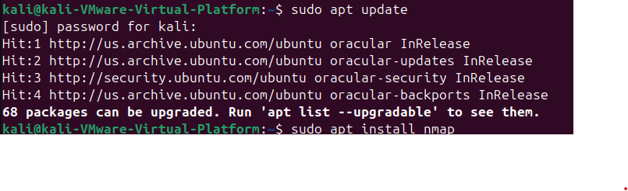End of Report

