Automate Something in Azure
Gabriel A. Hurtado
Aaron Rodriguez
University of Advancing Technology

Sign into the Azure portal
Locate the snapshot you want to use for restoring the VM. You can find snapshots in the "Snapshots" section under "All Services" or by searching for "Snapshots" in the search bar.
Click on the snapshot, and then click "Create VM" from the toolbar at the top. This will open the "Create a virtual machine" wizard.
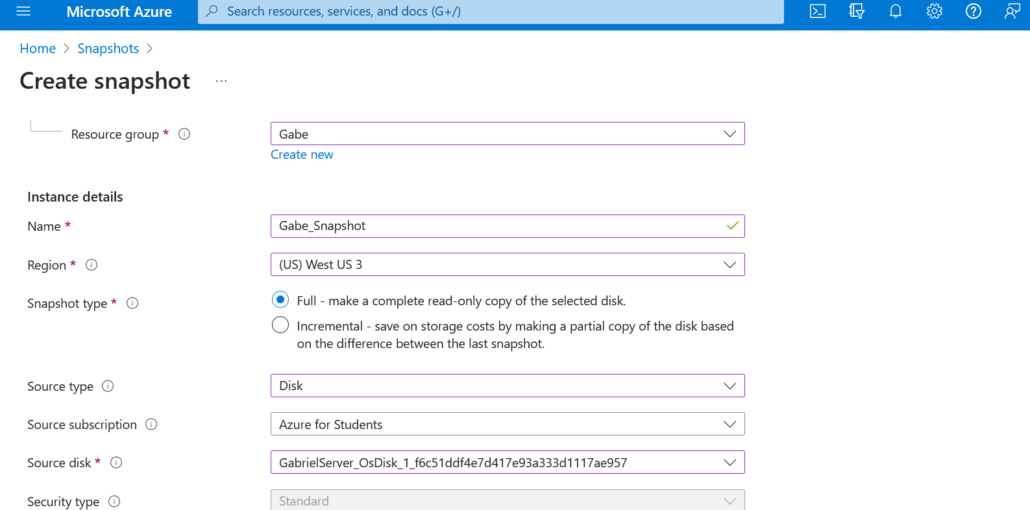
In the "Basics" tab, provide the following information:
Subscription: Choose the subscription you want to use.
Resource group: Select an existing resource group or create a new one.
Virtual machine name: Enter a name for the new VM.
Region: Select the region where you want to deploy the VM.
Availability options: Choose the appropriate availability option (e.g., Availability Zone, Availability Set, or No infrastructure redundancy required).
Image: The snapshot you selected will be used as the image.
Size: Choose the VM size based on your requirements.
Configure the remaining settings for the VM in the following tabs:
Disks: Configure the OS disk and data disks, if required.
Networking: Configure the virtual network, subnet, public IP, and network security group.
Management: Set up monitoring, diagnostics, and auto-shutdown settings, if necessary.
Advanced: Configure extensions, cloud-init, and other advanced settings as needed.
Tags: Add tags to help organize and categorize the VM, if desired.
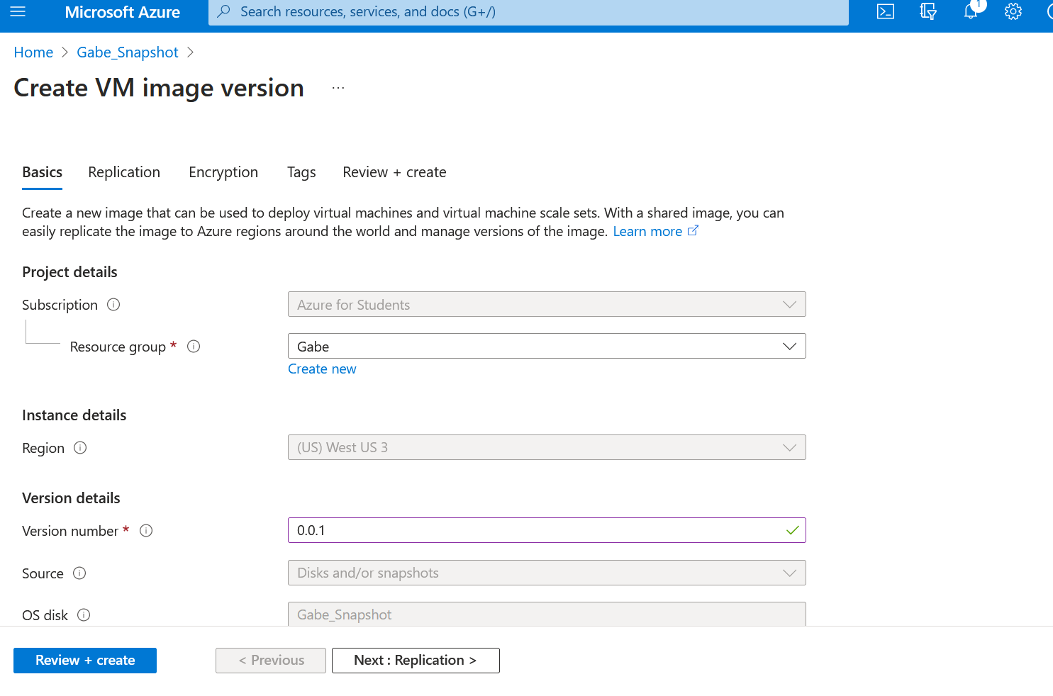
Review the settings in the "Review + create" tab. Make sure everything is configured correctly, and then click "Create" to start the deployment process. Azure will create the new VM using the selected snapshot as the OS disk.
Once the deployment is complete, navigate to the VM's "Overview" page to verify its status and settings. The VM should now be restored from the snapshot and ready to use.

To deploy a virtual machine (VM) from a template in Microsoft Azure, you can use an Azure Resource Manager (ARM) template. An ARM template is a JSON file that defines the resources and their configurations for your application.

First, prepare your ARM template.

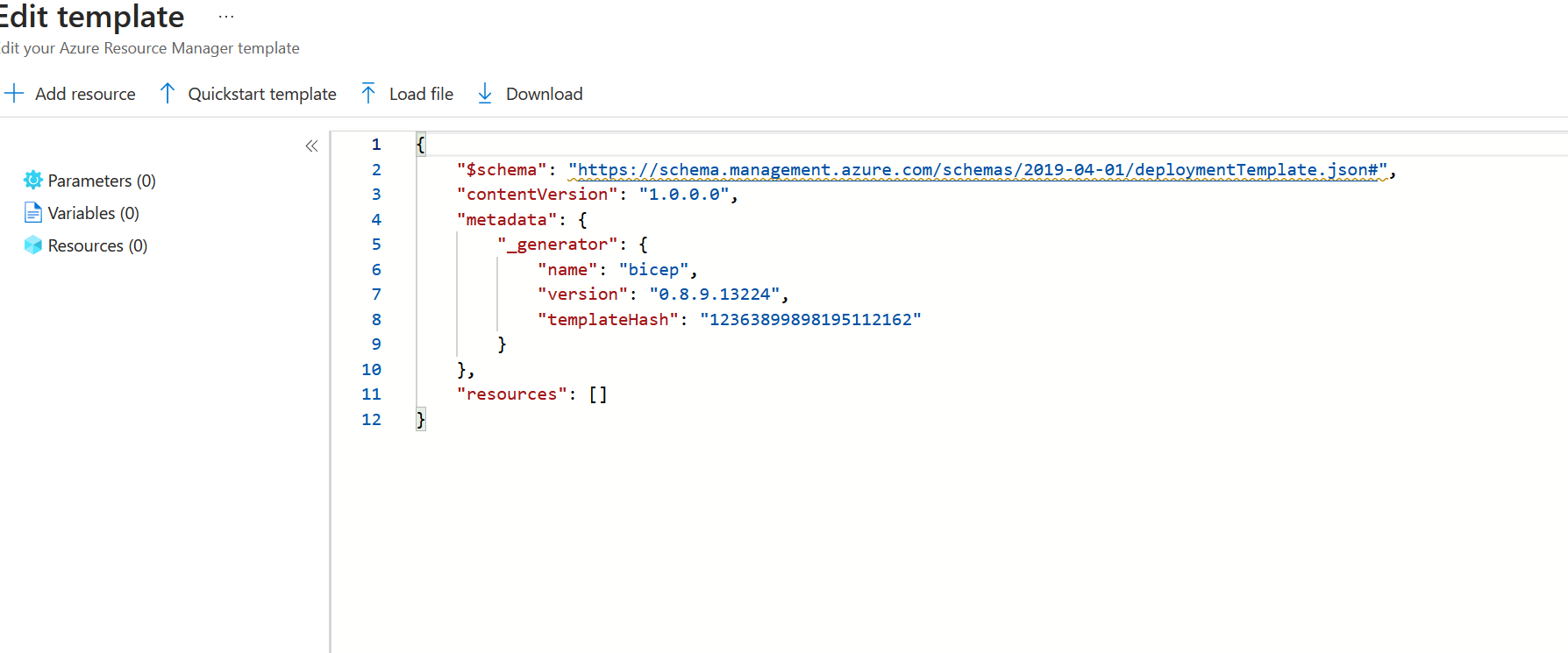
Save your ARM template as a JSON file (e.g., vm_template.json).
Sign in to the Azure portal (https://portal.azure.com).
Click on "Create a resource" in the left-hand menu.
In the search bar, type "Template deployment" and select it from the list.
Click the "Create" button to start deploying a new resource using a template.
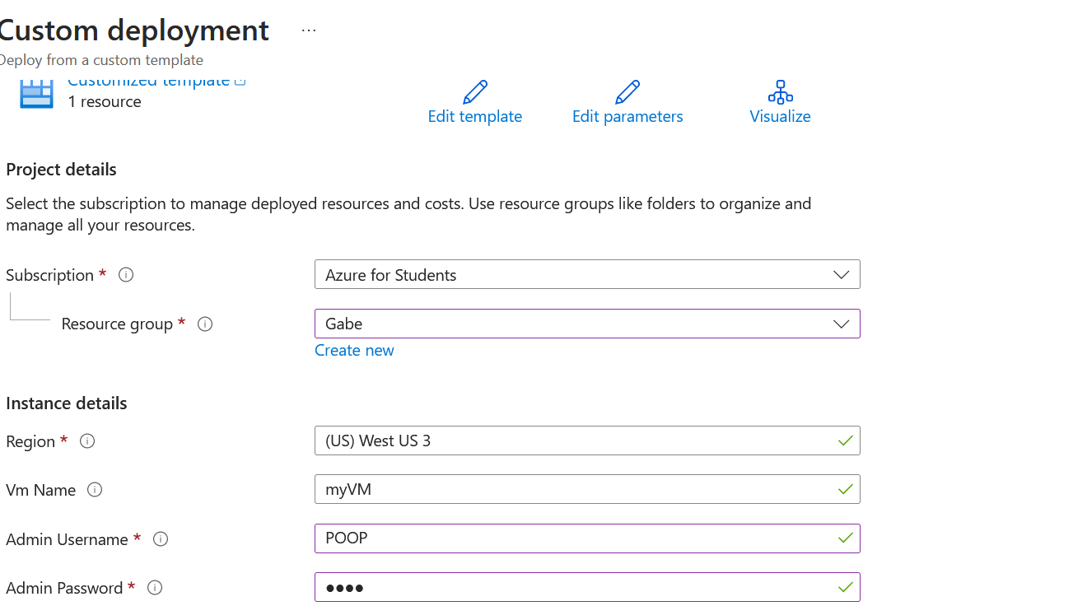
In the "Custom deployment" blade, fill out the following information:
  - Subscription: Choose the subscription you want to use.
  - Resource group: Select an existing resource group or create a new one.
  - Template: Click "Build your own template in the editor" and then upload or paste your ARM template JSON file.
Click "Save" to save your template.
In the "Parameters" section, provide the required input parameters for your template. In our example, you need to enter the VM name, admin username, and admin password.
Review the "Terms & Conditions," check the box to agree, and click the "Purchase" button to start the deployment.
Azure will now deploy
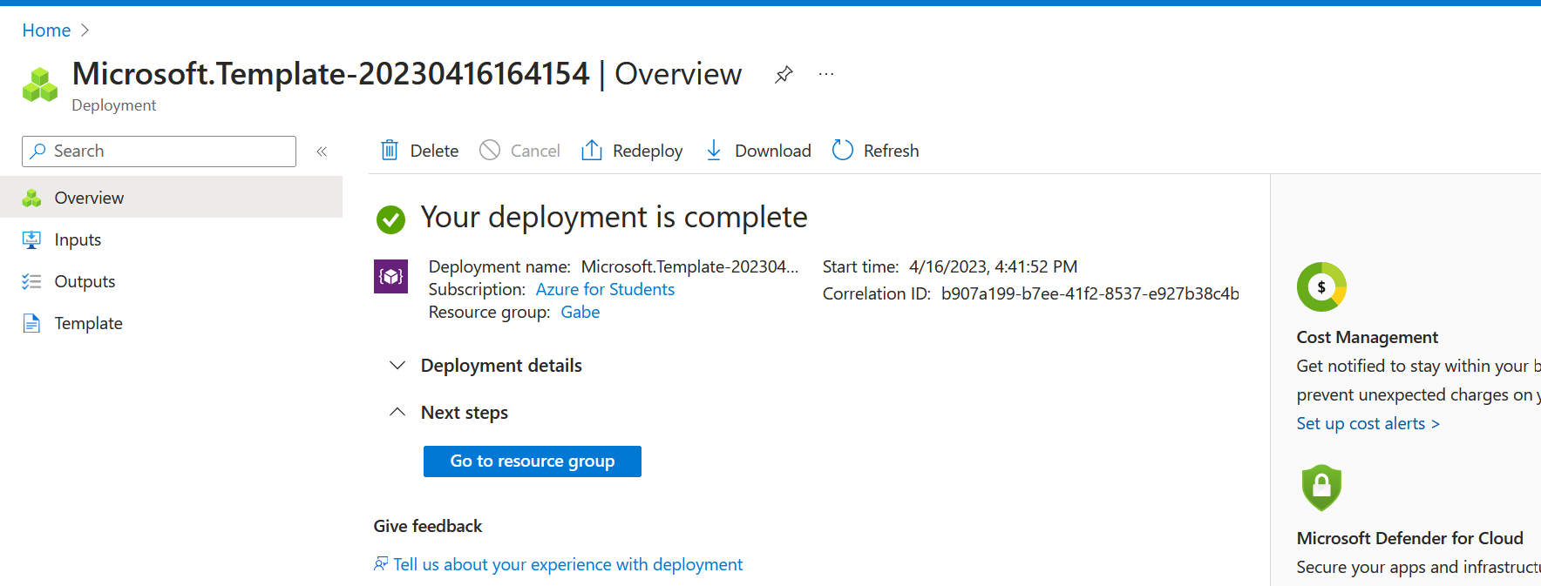

References
Finn, A. (2018, July 12). Copy An Azure VM Using Managed Disk Snapshots - Petri IT Knowledgebase. Petri IT Knowledgebase. https://petri.com/copy-azure-vm-using-managed-disk-snapshots/
Mumian. (2023, April 9). Deploy template - Azure portal - Azure Resource Manager. Microsoft Learn. https://learn.microsoft.com/en-us/azure/azure-resource-manager/templates/quickstart-create-templates-use-the-portal

