Final Project

Gabriel A. Hurtado

Dan Wilkins

University of Advancing Technology

Wargaming is a creative and strategic exercise that allows us to simulate and analyze potential conflicts, incidents, or disasters. By engaging in this process, decision-makers can visualize possible outcomes and devise effective response strategies based on the scenarios they create. In this essay, we will delve into the captivating world of wargaming an incident by weaving a hypothetical scenario, identifying potential events that could unfold, and discussing the response strategies we would employ.

A highly sophisticated cyber-attack is launched against a nation's power grid, triggering widespread power outages, chaos, and confusion. The attackers' sinister objective is to disrupt the nation's critical infrastructure, incite panic, and ultimately destabilize the government. As the nation's intelligence and cybersecurity agencies pick up on some indicators of the impending attack, they provide decision-makers with a limited window of opportunity to prepare and respond. The attackers exploit weaknesses in the power grid's control systems, causing a domino effect of failures that lead to widespread power outages. This event will likely have immediate and far-reaching consequences, affecting transportation, communication, and emergency services. As the power outage persists, fear and panic grip the population. People scramble to gather essential supplies, leading to shortages and price gouging. Misinformation and rumors run rampant on social media, further fueling the chaos.

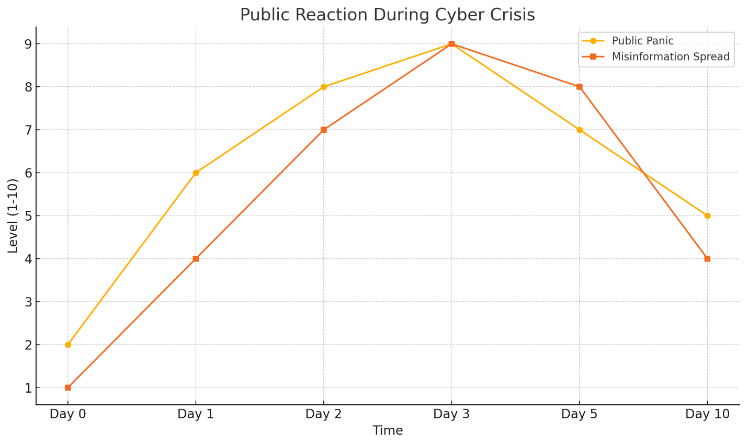

The attackers unleash secondary attacks, targeting emergency services, transportation systems, and financial institutions. These attacks are designed to compound the chaos and magnify the impact of the initial attack. As the nation grapples with the crisis, geopolitical tensions escalate. Neighboring countries may seize the opportunity to advance their interests, leading to heightened tension and even the potential for military conflict. In the early stages of the wargame, we must focus on preparation. This includes bolstering cybersecurity measures, ensuring emergency response plans are up-to-date, and fostering clear communication channels between relevant stakeholders. Additionally, public awareness campaigns highlighting the importance of cybersecurity and offering guidance during power outages can help minimize panic and misinformation during the incident.

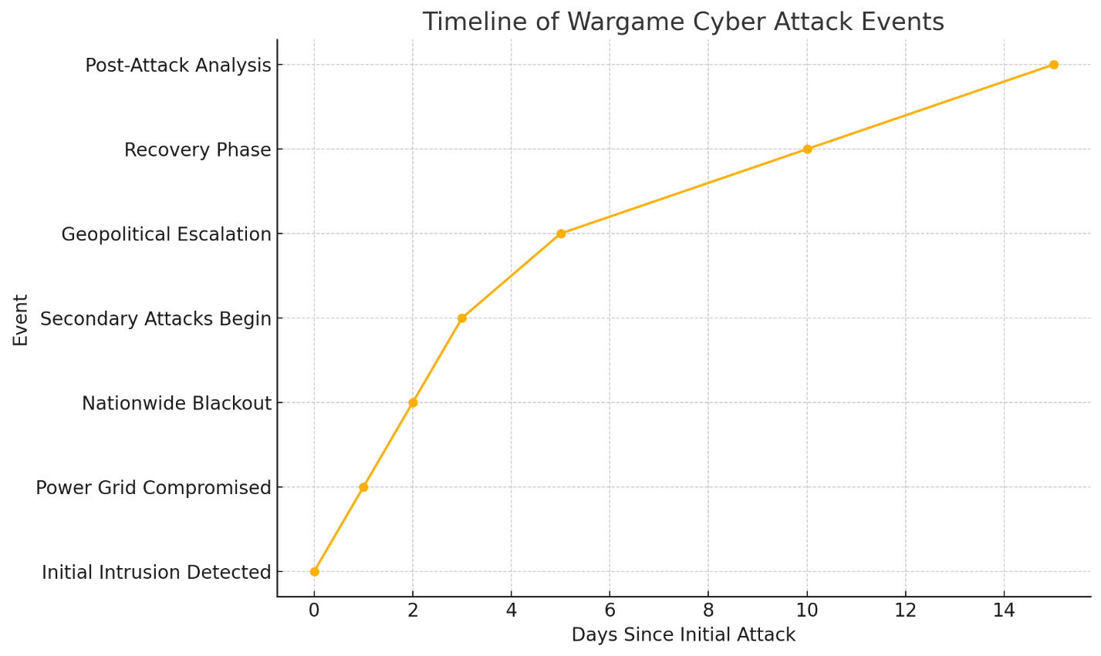

As the attack unfolds, a rapid response is paramount. We must prioritize detecting the source of the attack and mitigating its effects. This may involve dispatching cybersecurity teams to locate and neutralize the attackers, as well as collaborating with utility companies to isolate affected systems and restore power where possible.

Alongside the technical response, we must manage the public's reaction to the crisis. This includes providing accurate and timely information through traditional and social media channels to counteract misinformation and rumors. Additionally, working together with law enforcement and emergency services to maintain public order and ensure the safety of the population is essential. In the aftermath of the attack, we must focus on restoring critical infrastructure and services while learning from the incident to enhance our preparedness and resilience. This could involve investing in cutting-edge technologies or upgrading existing systems to better protect against future cyber-attacks.

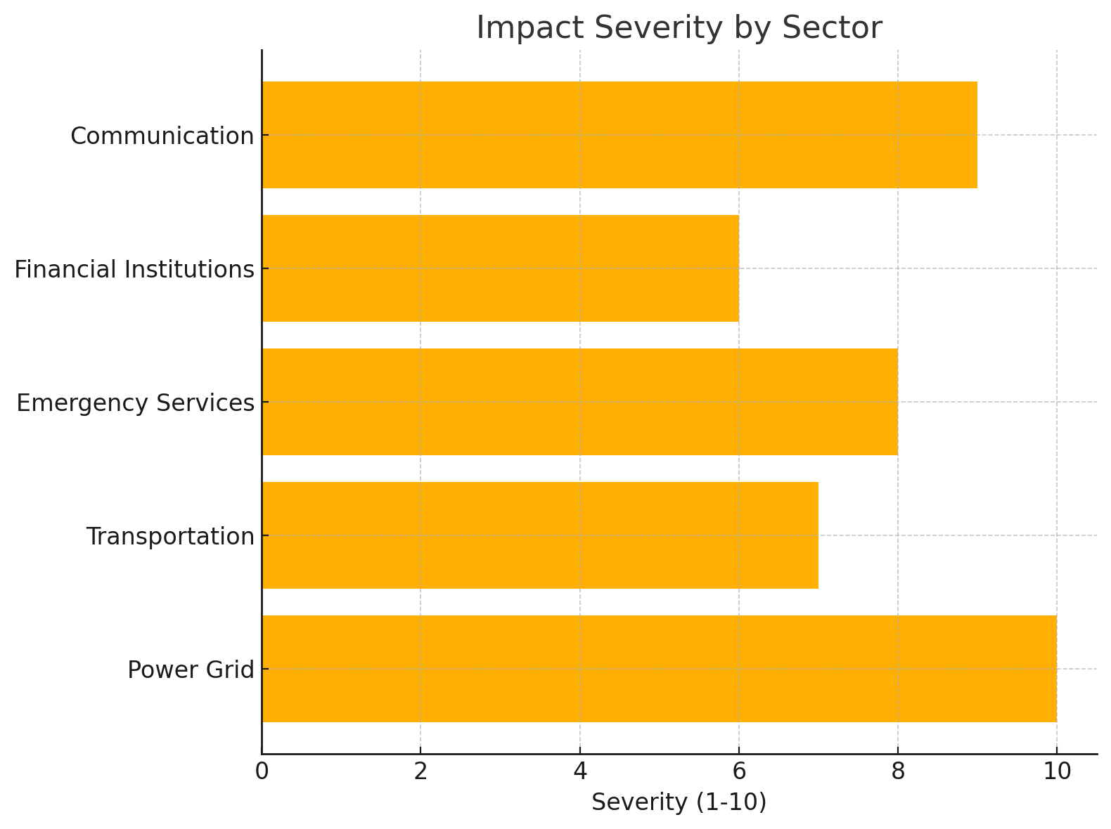

Finally, we must consider the broader geopolitical implications of the incident. This may involve identifying and holding the perpetrators accountable through diplomatic, economic, or even military means. Moreover, collaborating with international partners to strengthen global cybersecurity norms and cooperation can help deter future attacks and promote stability.

Engaging in an incident wargame, such as a cyber-attack on a power grid, allows decision-makers to delve into a world of possibilities and better understand the potential consequences of various scenarios. By crafting a captivating narrative, anticipating events that could unfold, and developing comprehensive response strategies, nations can increase their preparedness and resilience against such threats. Ultimately, wargaming is an invaluable tool that not only fosters strategic thinking but also empowers us to confront uncertainties and challenges in a proactive manner. By embracing this creative and insightful approach, we can ensure a more secure and stable future for all.