Final Project
Gabriel A. Hurtado
Aaron Rodriguez
University of Advancing Technology

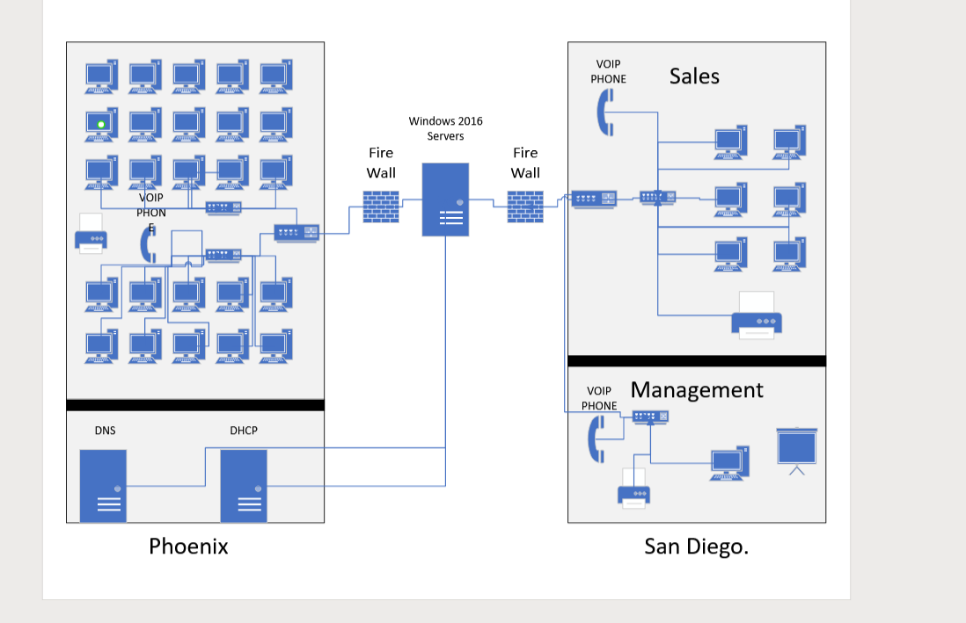
Hello, for my final I will be upgrading the computer networks for a company with two offices in San Diego and Phoenix. First, it's very important to create a plan that caters to the requirements of both locations. First, we need to examine the existing network, identify any serious issues, and design a more efficient network. This process will involve replacing outdated equipment, enhancing the connection between the two offices, updating servers, and setting up systems for IP address assignments and user account management. Plus, incorporating a VoIP solution will simplify communication between offices while reducing costs.
There are many companies that offer network equipment for small to medium business I think Cisco is a good choice for this company. Cisco offers a diverse range of network equipment that caters to businesses of all sizes and needs. For routers, small businesses or branch offices can benefit from the Cisco ISR 1100 Series, while medium to large businesses might prefer the more powerful Cisco ISR 4000 Series. In the case of switches, the Cisco Catalyst 2960-X Series is a popular and reliable option for small to medium-sized businesses, while the advanced and scalable Catalyst 9300 Series is perfect for more demanding environments. For wireless connectivity, consider the Cisco Aironet 1830 Series for smaller businesses, and the cutting-edge Catalyst 9100 Series, which supports Wi-Fi 6, for more extensive networks.
Additionally, Cisco offers firewalls like the ASA 5500-X Series, ideal for small to medium-sized businesses, and the high-performance Firepower 2100 Series for larger organizations. For VoIP solutions, the Cisco IP Phone 7800 Series delivers essential telephony features, while the IP Phone 8800 Series offers advanced capabilities such as video calling and Wi-Fi support. It's crucial to keep your company's present and future requirements in mind, including user numbers, desired features, and scalability, when selecting specific models. Remember that Cisco provides a variety of product lines, and the mentioned models serve as a starting point. Thorough research and comparison will help you find the best network equipment to fit your business needs.
The next phase of the upgrade is to install Windows 10 on all computers, ensuring they connect seamlessly to the new network. This includes automatic domain joining, compliance with rules set by the Domain Controllers, and access to VoIP services. It's also essential to establish a monitoring system to track network performance, detect any issues, and send alerts as needed. Keeping the network in check and updating it regularly is crucial for maintaining optimal performance and security.
Lastly, it's vital to train employees on the new network, Windows 10, and VoIP services, providing continuous support to address any questions or concerns. Developing a detailed plan and budget, including project milestones and costs, will help keep the project on track. Implementing the upgrade in stages minimizes interruptions, and closely monitoring progress ensures everything runs smoothly, allowing for prompt resolution of any issues that may arise.

To set up 60 user accounts for a company split between two offices, you'll want to start by collecting employee information, such as names, job titles, departments, and office locations. You'll also need to know what computer resources they require for their work. Once you have that info, decide on a consistent method for creating usernames and temporary passwords. You'll also need to plan how to organize shared folders and consider any special rules or group memberships needed for various roles.
Now it's time to create the accounts. For the Phoenix office, you'll need to make 50 accounts, with 40 of them for the call center and 10 for other roles. In the San Diego office, create 10 accounts for management and sales teams. Once the accounts are set up, make sure to grant users access to the appropriate folders and resources according to their roles.
Next, get everyone's email accounts up and running, and share their account details with them, including instructions on changing their temporary passwords. Finally, double-check that all accounts have been correctly created and keep an eye on account activity to ensure everything stays secure and in line with company policies.

References
How to Set Up a Small Business Network. (2022, December 26). Cisco. https://www.cisco.com/c/en/us/solutions/small-business/resource-center/networking/how-to-set-up-a-network.html

Lovinus, A. (2021, January 14). How-to Guide: Small Office Network Setup - Newegg Business Smart Buyer. Smart Buyer. https://www.neweggbusiness.com/smartbuyer/over-easy/small-office-network-setup/

