Configure DNS

Foundation of Systems Administration

Gabriel A. Hurtado

University of Advance Technology

Rodriguez Aaron

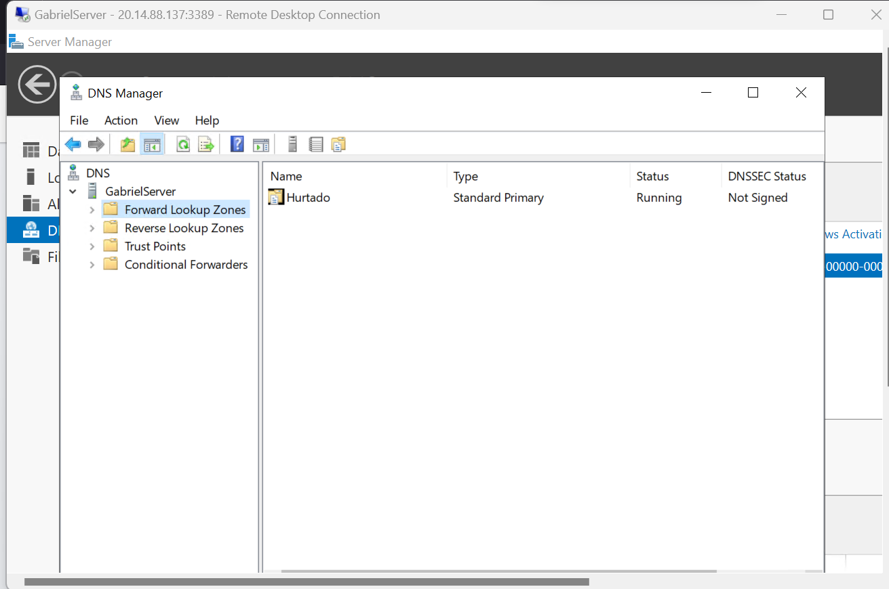
Create a new zone
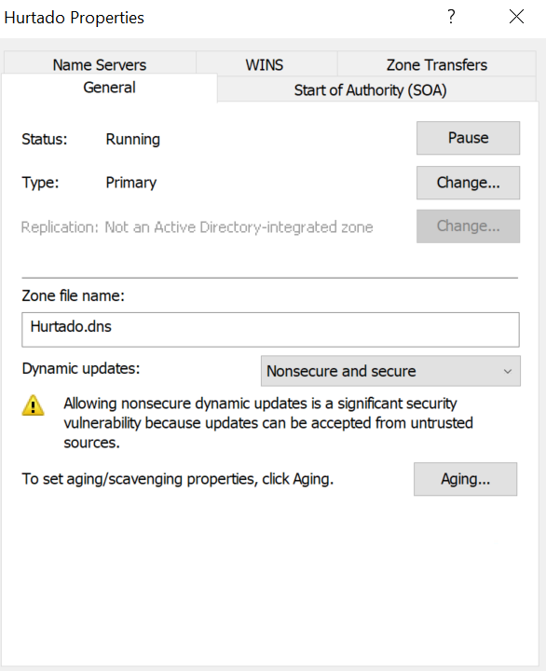
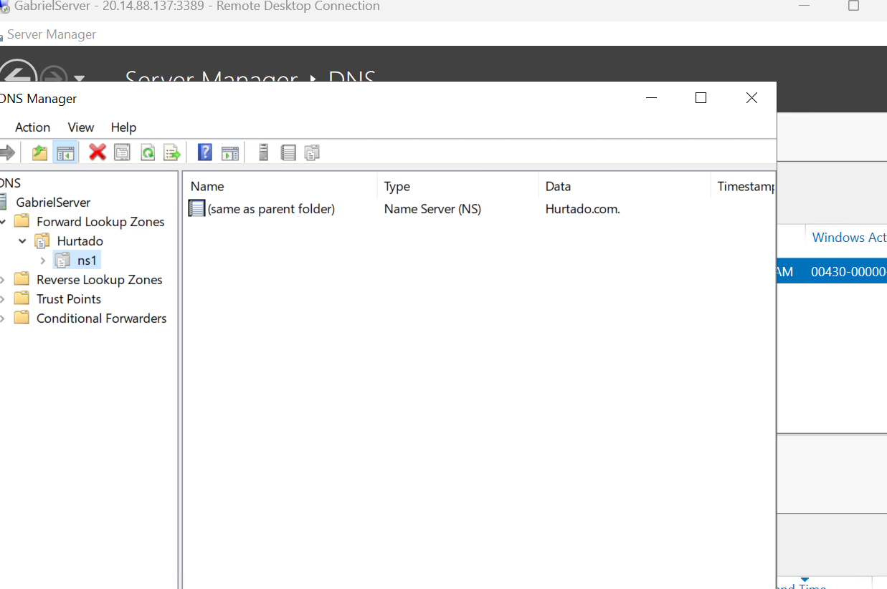
Create a new Delegated Domain
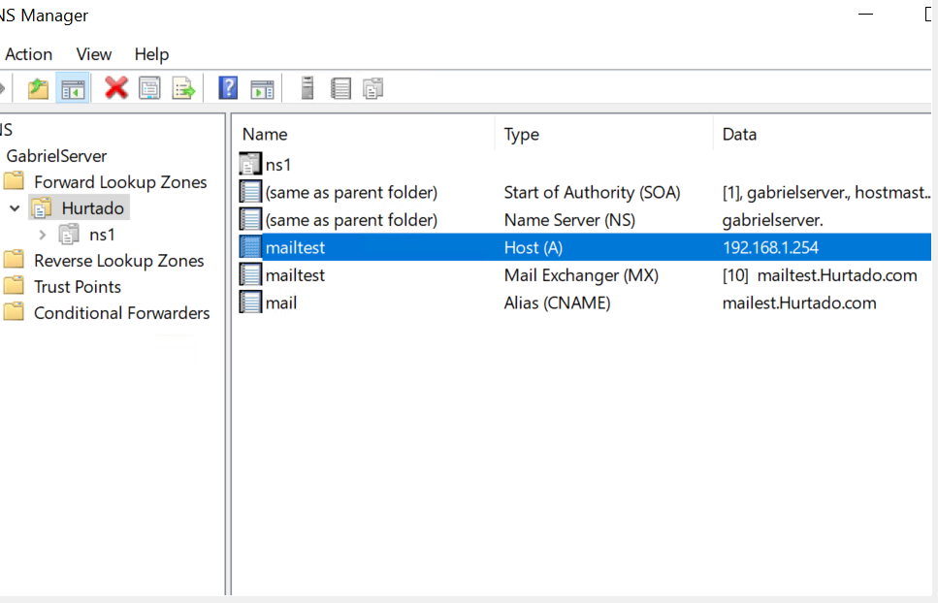
Manually Create DNS RRs

Summery

In order to configure DNS using Windows Server Manager, you must first add the DNS server role, then choose the appropriate features and settings, and then install the required components. Users can start DNS Manager as soon as the installation process is finished so that they may establish and manage DNS zones, records, and settings for their network. Setting up DNS on a Windows Server is a straightforward and time-saving operation thanks to the intuitive interface of Server Manager and the step-by-step instructions it provides.

References

Panek, W. (2018). MCSA Windows Server 2016 Complete Study Guide: Exam 70-740, Exam 70-741, Exam 70-742, and Exam 70-743 (2nd ed.). Wiley Professional Development (P&T). https://online.vitalsource.com/books/9781119359159

